1.select * from movie;

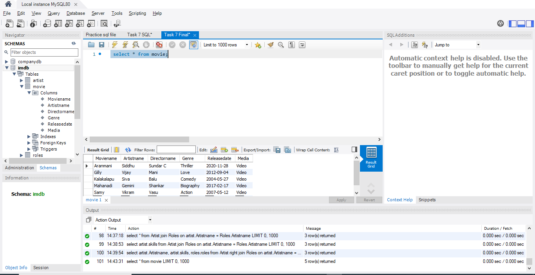

2.select * from Review;
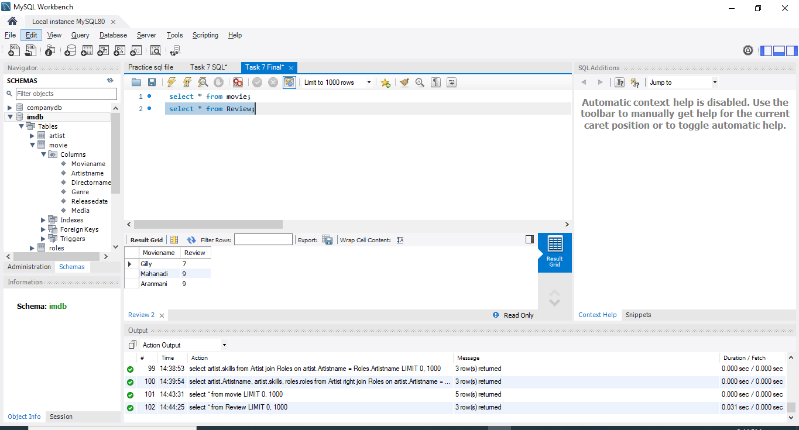

3.select * from artist;
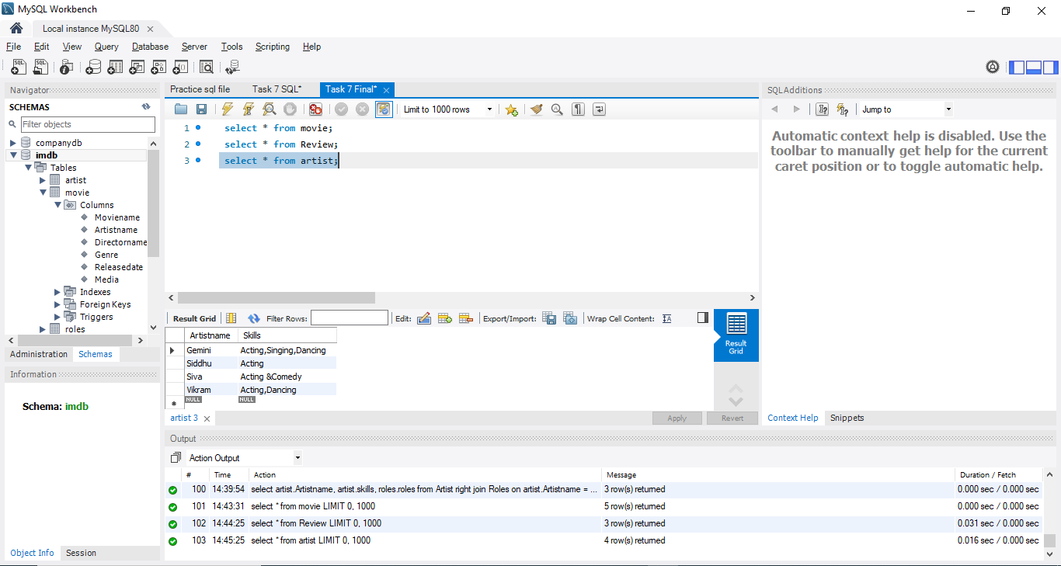

4.select * from Roles;
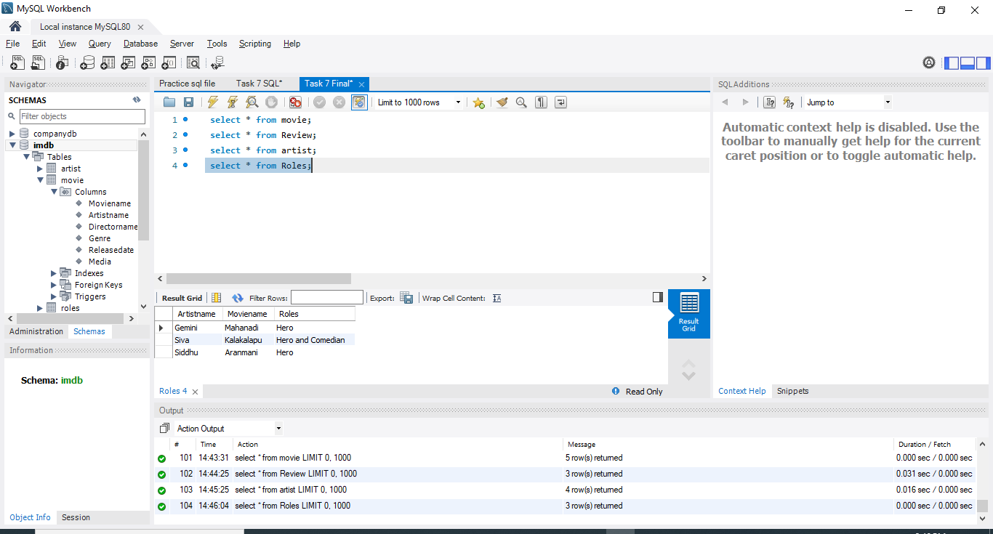

5.Fetching details from both Movie and Review tables which are all have the same movie name using INNER JOIN:
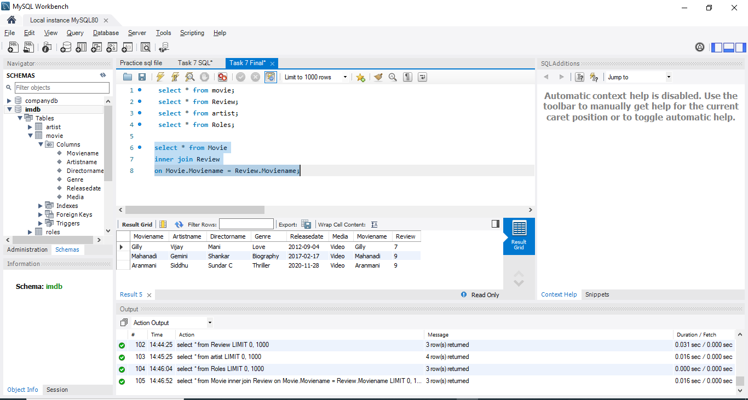

6. Fetching details from both Movie and Review tables using RightJOIN:
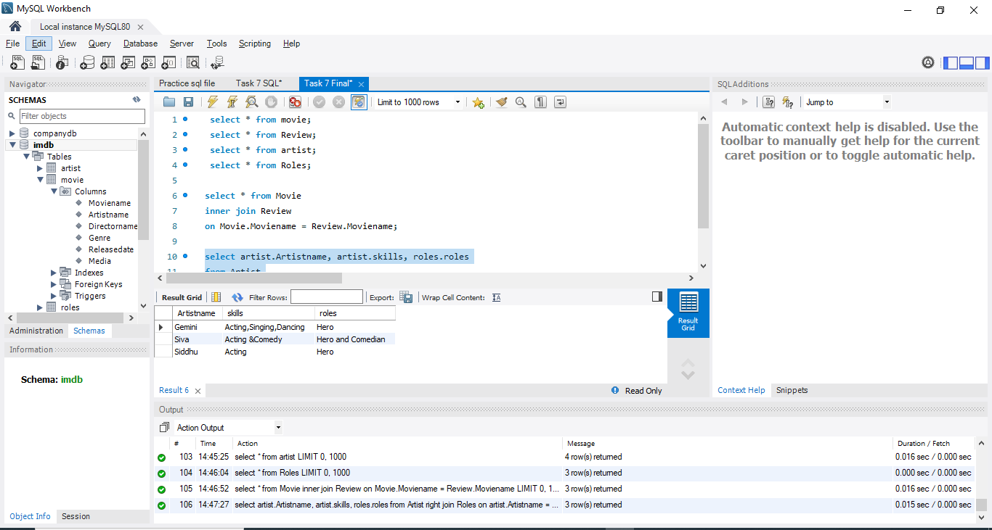

7. Fetching details from all the tables using multiple JOIN:
